Predicting Exoplanets by Model Fitting Kepler Object of Interest Data

David G. Kinney

Bellevue University

DSC 680 – Professor Catherine Williams

Abstract

The NASA Exoplanet Archive is an online astronomical exoplanet and stellar catalog and data service that collates and cross-correlates astronomical data and information on exoplanets and their host stars. These data include stellar parameters (such as positions, magnitudes, and temperatures), exoplanet parameters (such as masses and orbital parameters) and discovery/characterization data (such as published radial velocity curves, photometric light curves, images, and spectra). [1]

Keywords: exoplanet, NASA

Predicting Exoplanets by Model Fitting Kepler Objects of Interest Data

The body of your paper uses a half-inch first line indent and is double-spaced. APA style provides for up to five heading levels, shown in the paragraphs that follow. Note that the word Introduction should not be used as an initial heading, as it’s assumed that your paper begins with an introduction.

# Heading 1

The first two heading levels get their own paragraph, as shown here. Headings 3, 4, and 5 are run-in headings used at the beginning of the paragraph.

## Heading 21

For APA formatting requirements, it’s easy to just type your own footnote references and notes. To format a footnote reference, select the number and then, on the Home tab, in the Styles gallery, click Footnote Reference.

### **Heading 3.**

Include a period at the end of a run-in heading. Note that you can include consecutive paragraphs with their own headings, where appropriate.

#### ***Heading 4.***

When using headings, don’t skip levels. If you need a heading 3, 4, or 5 with no text following it before the next heading, just add a period at the end of the heading and then start a new paragraph for the subheading and its text. (Last Name, Year)

##### *Heading 5.*

Like all sections of your paper, references start on their own page, as you see on the page that follows. Just type in-text citations as you do any text of your paper, as shown at the end of this paragraph and the preceding paragraph. (Last Name, Year)

To see this document with all layout and formatting, such as hanging indents, on the View tab of the ribbon, click Reading View.

References

[1] NASA Exoplanet Archive – NASA Exoplanet Science Institute <https://exoplanetarchive.ipac.caltech.edu/index.html>

Last Name, F. M. (Year). *Book Title.* City Name: Publisher Name

Footnotes

1Add footnotes, if any, on their own page following references. The body of a footnote, such as this example, uses the Normal text style. (Note: If you delete this sample footnote, don’t forget to delete its in-text reference as well. That’s at the end of the sample Heading 2 paragraph on the first page of body content in this template.)

Tables

Table 1

Table Title

| Column Head | Column Head | Column Head | Column Head | Column Head |
| --- | --- | --- | --- | --- |
| Row Head | 123 | 123 | 123 | 123 |
| Row Head | 456 | 456 | 456 | 456 |
| Row Head | 789 | 789 | 789 | 789 |
| Row Head | 123 | 123 | 123 | 123 |
| Row Head | 456 | 456 | 456 | 456 |
| Row Head | 789 | 789 | 789 | 789 |

Note: Place all tables for your paper in a tables section, following references (and, if applicable, footnotes). Start a new page for each table, include a table number and table title for each, as shown on this page. All explanatory text appears in a table note that follows the table, such as this one. Use the Table/Figure style, available on the Home tab, in the Styles gallery, to get the spacing between table and note. Tables in APA format can use single or 1.5-line spacing. Include a heading for every row and column, even if the content seems obvious. A table style has been setup for this template that fits APA guidelines. To insert a table, on the Insert tab, click Table.

Figures

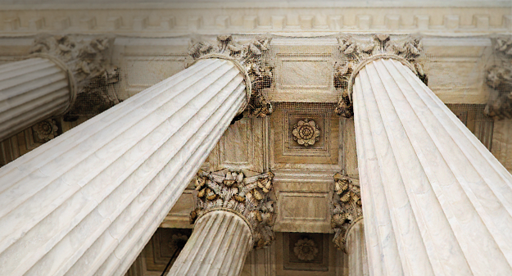

Figure 1. Include all figures in their own section, following references (and footnotes and tables, if applicable). Include a numbered caption for each figure. Use the Table/Figure style for easy spacing between figure and caption.

For more information about all elements of APA formatting, please consult the APA Style Manual, 6th Edition.